HOW TO VISIT THE CLARKE COLLEGE ALUMNI HOUSE

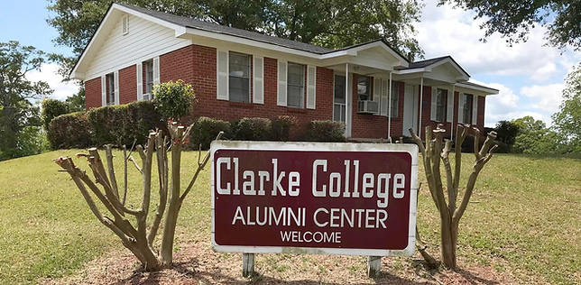

Welcome to the Alumni House where you’ll find assorted memorabilia to help you relive your days at Clarke College. We hope you enjoy your visit!
The procedure for accessing the Clarke College Alumni is easy and straightforward.
- Go to CMRC Welcome Center on front of campus on Highway 80; the address is 701 Northside Drive, Newton, MS 39345.
- Identify yourself and request access to the Alumni House.
- Complete registration log: name, phone, driver’s license, number of visitors, purpose of visit and years you attended Clarke are the required items.
- Security personnel will provide you access code for keypad on front door.
- If needed, the address of the Alumni House is 101 McMullan Avenue, Newton, MS 39345. It’s within sight of the Welcome Center where you will register.
- When finished, remove all food and drinks you may have placed in the refrigerator and take it with you; place all trash in receptables; turn off all lights, lock all doors, & advise Welcome Center that visit is completed & building is vacant.
- We hope your visit is comfortable, enjoyable and nostalgic. Please let us know if anything needs our attention.

